How to measure a tube socket for an open circuit.
- Remove tube from tube socket and store it in a safe place to avoid any damage. See photos below.
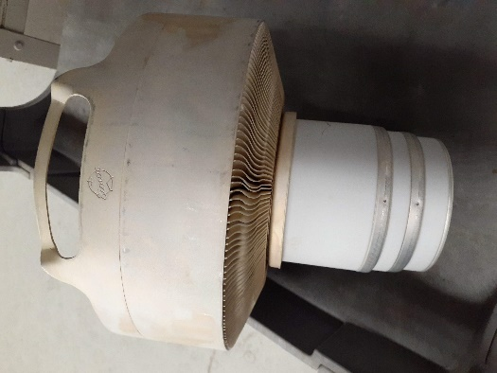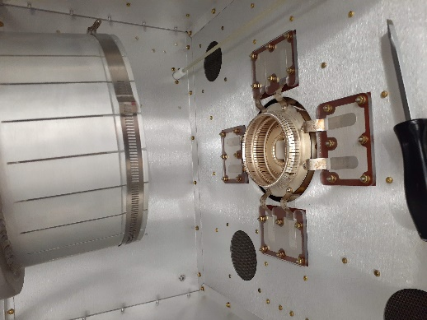
- With an ohm’s meter measure the outside ring (Screen Circuit) for resistance. Reading should be close to 10K Ohms. See photo and schematic below. If open, check R209 and R210 for 5K ohms. Also check R4 for 1.5 ohms, which is under the socket assembly. See photo below. R209 and R201 Part # 180-0578 and R4 Part # 132-0114
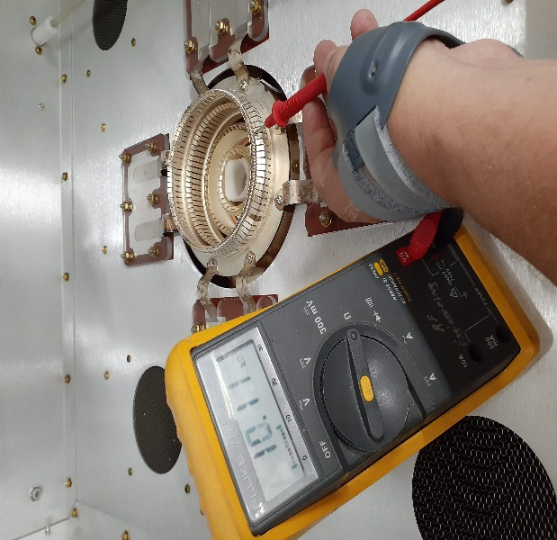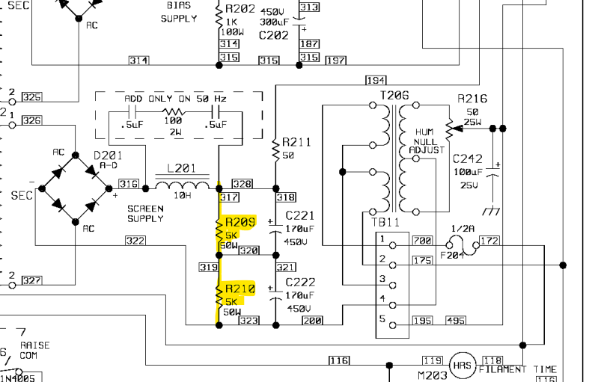
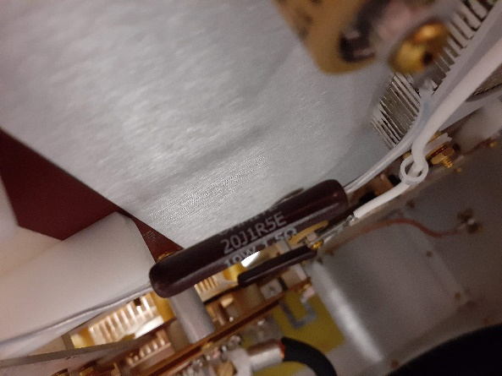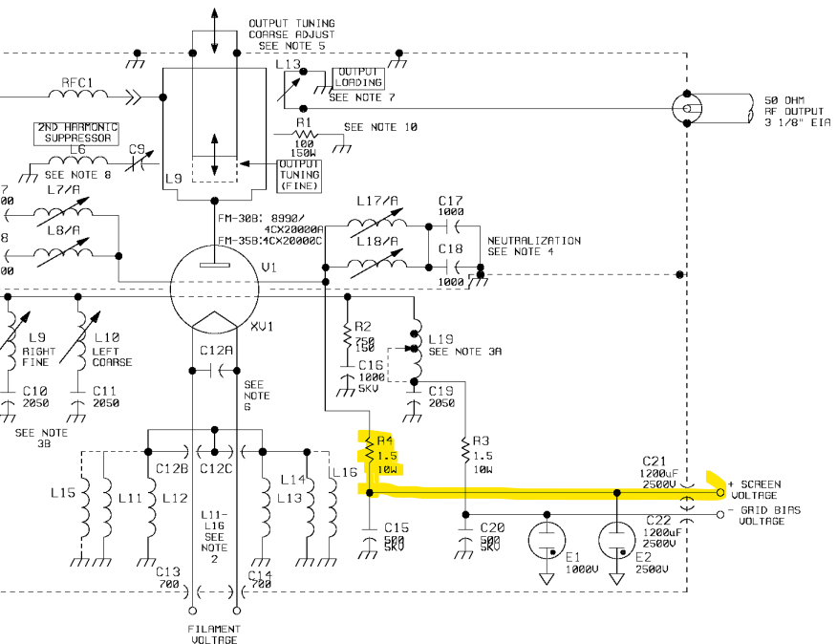
- With an ohm’s meter measure the 2nd ring (Grid Circuit) inside the socket. Reading should be somewhere around 1.5K to 5K ohms (FM25, 30, & 35T =1.5K Ohms, FM20T= 2.5K Ohms, FM10T= 3.5K Ohms, & FM5T = 5K Ohms). See photo and schematic below. If open, check R214 for 500 ohms and R202 for 1K ohms. Also check R3 for 1.5 ohms, which is under the socket assembly. See photo below. R214 Part # 130-5033 and R202 Part # 132-1043 and R3 Part # 132-0114
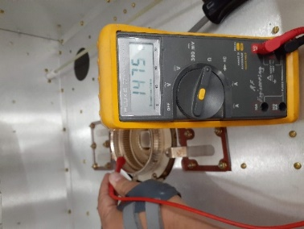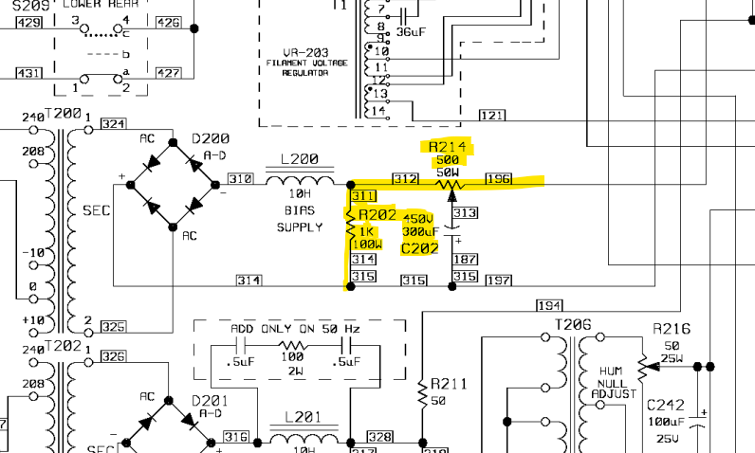
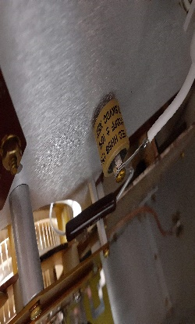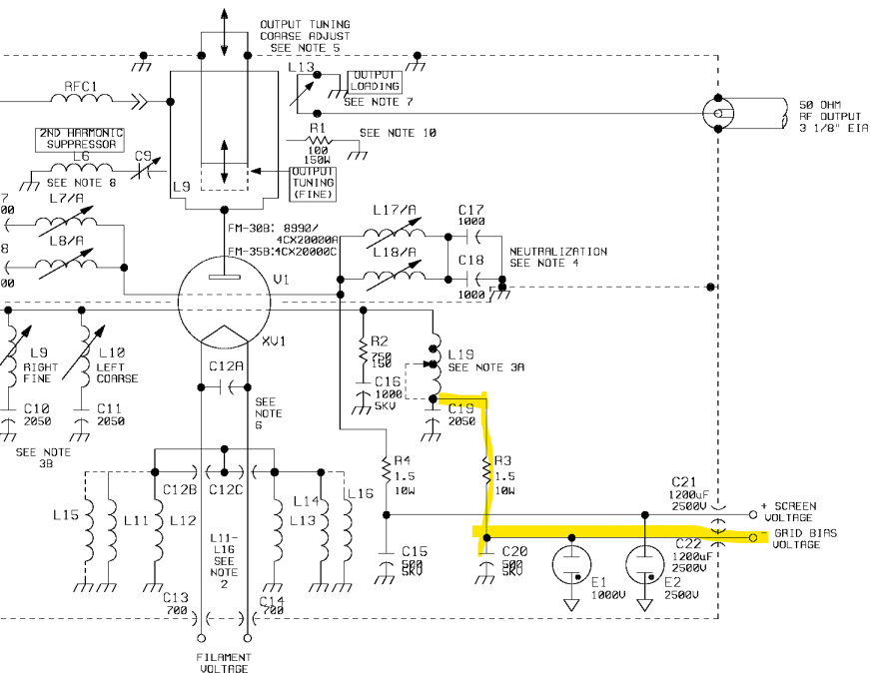
- With an ohm’s meter measure the next 2 rings (Filament) in the middle of the socket. Reading should be ground. See photos below. If open it could be the wire fuse on the PA Meter Shunt Board. See photo below.
