**Instructions on changing a 959-0800 PA Pallet**

**Note:** **This procedure should be preformed in a repair facility where there is good lighting, grounding, and a proper temp controlled soldering iron.**

1. Remove the bottom lid of the STXe to access the PA Section

2. You will see the PA Pallets as shown in the pictures below. There is a total of 4. You will need to remove the metal bracket going down the middle of the Pallets to gain access to them.

A. Unsolder both sides of the feedthroughs going through the metal bracket holding the PA Pallets down. There is a total of 4 and both sides will need to be unsoldered. These can be seen in picture 1 and 2 and the only parts going through the bracket.

B. Remove the 7 black screws as seen in picture 2 on the small tabs on the metal bracket. They are directly up next to the bracket holding it down to the bottom chassis.

C. Cut the ty wrap holding the white cables to the bracket.

D. Lyft the bracket out. You will now have access to the 4 pallets.

3. select the pallet you want to remove and replace.

**Note: Look at the pallets from the front with the unit upside down, Pallet 1 is on the right and counts right to left. To verify you are on the correct pallet, the small black cable the plugs into the pallet from the PA interface card will be labeled J1 for pallet 1, J2 for pallet 2, etc.**

A. Unplug the black cable from the pallet you with to remove.

B. Unsolder the white wire from the pallet (Same side as the black wire that was removed)

C. unsolder copper tab from pallet input from splitter (same side as black wire that was removed)

D. unsolder copper tab from output side of pallet connecting it to combiner.

E. Unsolder the one lead on both large white resistors connected to the left and right side on the output of the pallet. You will then bend the lead up so the board will clear the leads

F. Remove the 8 black screws holding the pallet in place. (4 on each side)

G. Remove the 2 screws holding the transistor clamp down to the top of the power transistors.

H. Gentle lift the pallet out of the transmitter.

I. Apply a then layer of thermal compound under the transmitter and place the new pallet in place.

J. Apply the transmitter clamp and 8 screws back into the pallet to hold it in place.

K. Resolder the 2 white resistors, Both Copper straps (one on input and one on output), Solder white wire back on. Plug in black wire.

L. Reinstall metal bracket with the 7 black screws

M. Resolder both sides of the feedthroughs to the pallet.

N. Install new ty wrap to white wire to metal bracket to hold in place.

Recheck everything against other pallets to make sure all connections are made and to the correct point.

This completes the Pallet replacement procedure.

Picture 1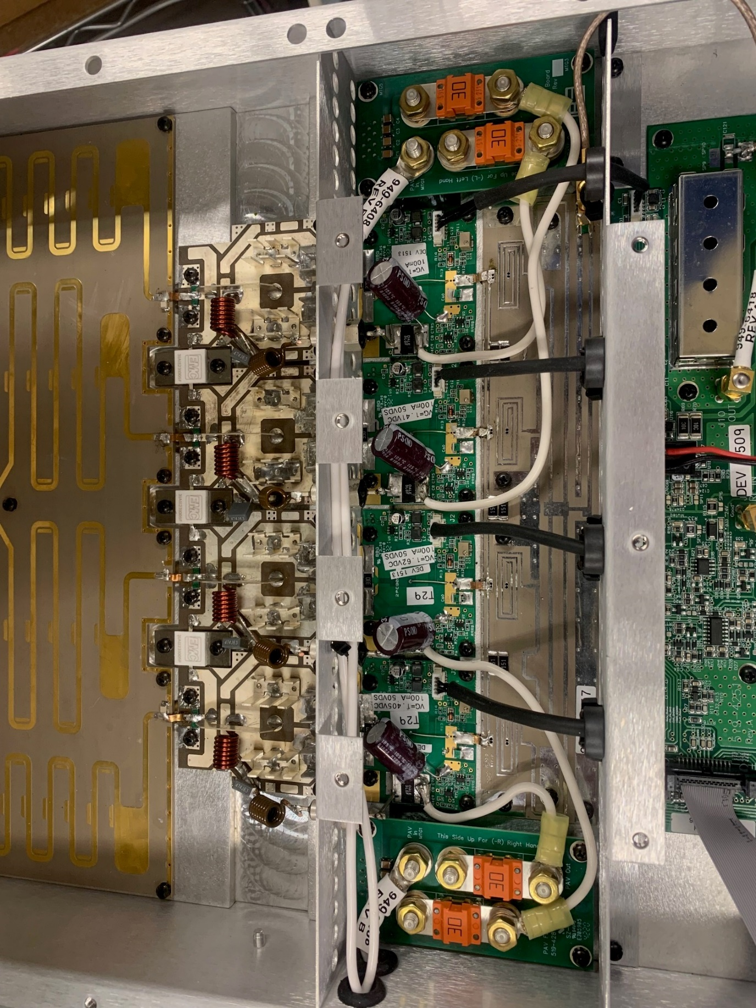

Picture 2

