AM TX LVPS CHANGEOUT
- Shut off AC power to the transmitter.
- Open the ECU cabinet (957-0009-011) front door.
- Pull out the ECU Controller Board (917-0205) and set aside. This will give you more room to remove the LVPS (540-0006). *NOTE: ECU CONTROLLER BOARD CAN BE A SNUG FIT AND CAN TAKE 2 HANDS TO PULL OUT AND PUT BACK IN.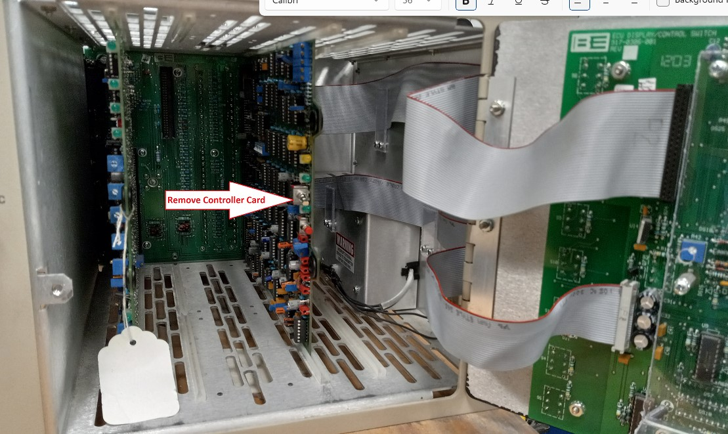
- Unplug the bottom ribbon cable (P10) from rear and dress it out of the way of the LVPS. 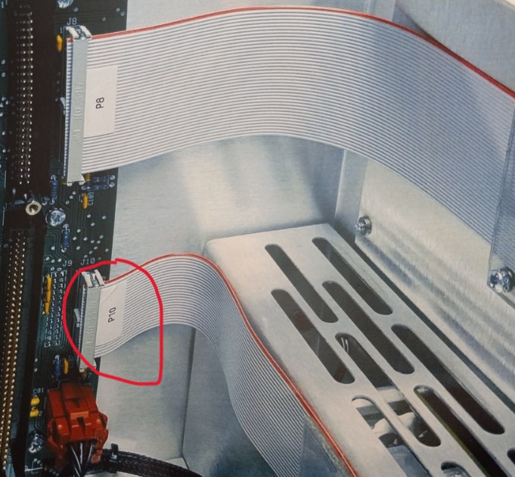
- Locate the LVPS and cut the 2 cable ty-rap (402-000) that hold the cable to the LVPS cover (471-0848). 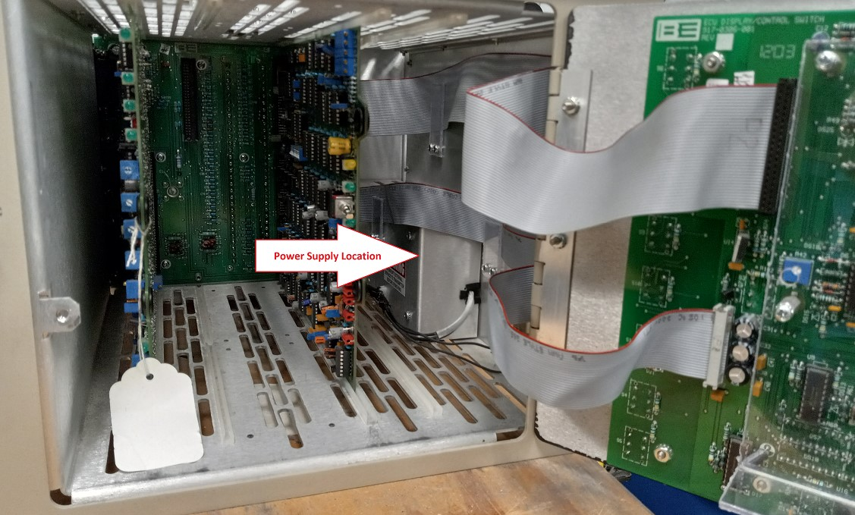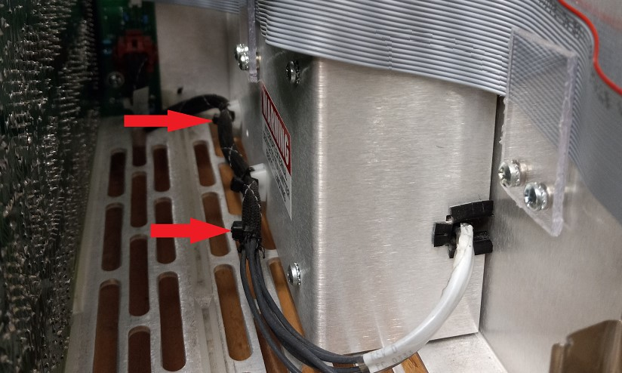
- Remove the 4 screws (422-6106) holding the LVPS cover by using a #1 Phillips head screwdriver. Set LVPS cover aside.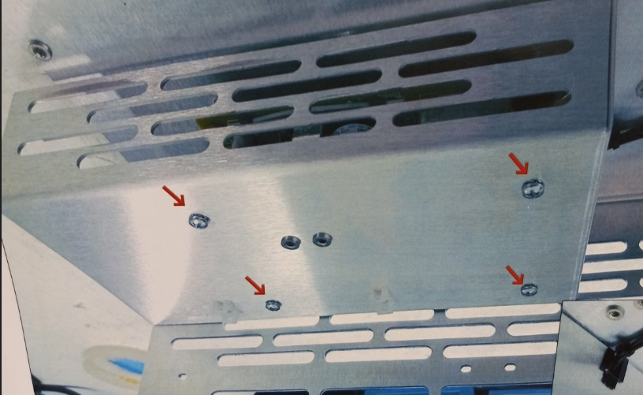
- Unplug cables P1 and P2 from the LVPS and dress aside. 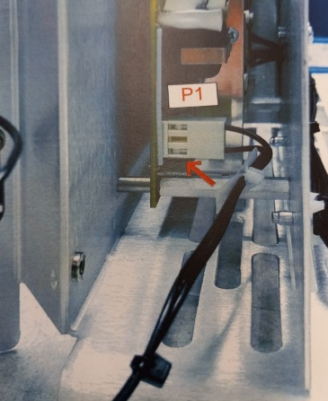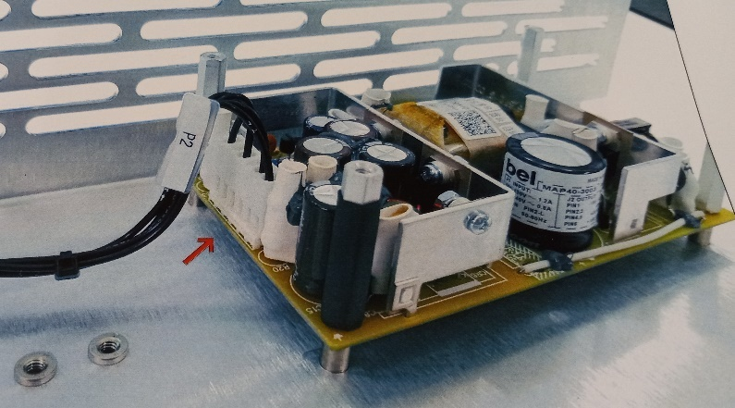
- Remove the 4 standoffs (441-0068) and 4--#6 split locks (423-6002) that are keeping the LVPS in place with a ¼” nut driver or wrench. Set this hardware and stand off aside. 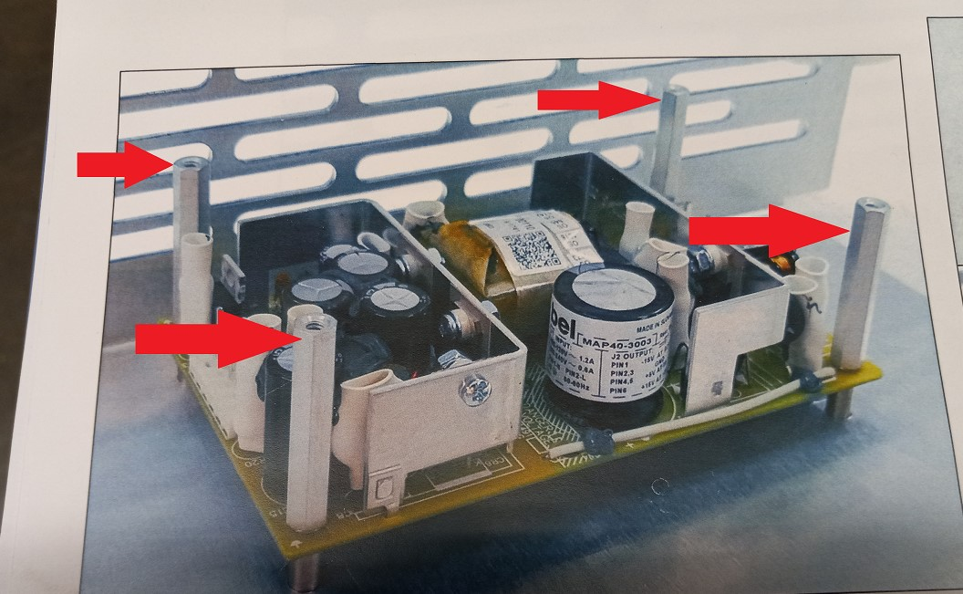
- Remove the LVPS from the ECU and replace it with the new one.
INSTALLING NEW LVPS
- Work backwards from Step 8 to Step 3 putting everything back in.
- Put the new LVPS in place of the bad LVPS.
- Reinstall the 4 standoffs and split locks.
- Plug in P1 and P2 cables back in.
- Put cover back on with the 4 screws.
- Dress P7 cable along the LVPS cover and use 2 ty-raps to hold them in place with the cable ty plugs.
- Plug ribbon cable P10 back into the motherboard. Make sure you have this lined up correctly. There is no key or guidance slot plugging this into the board. It can be off by 1 pin very easily and cause errors on the transmitter.
- Plug ECU Controller back into place. * IT MAY TAKE BOTH HANDS TO PUSH THIS IN. IT IS VERY TIGHT AND YOU SHOULD FEEL IT SNAP INTO PLACE.
- Turn AC power back on and you should be ready to turn back on.
THIS IS ALSO A GOOD TIME TO REPLACE THE +9V BATTERY.
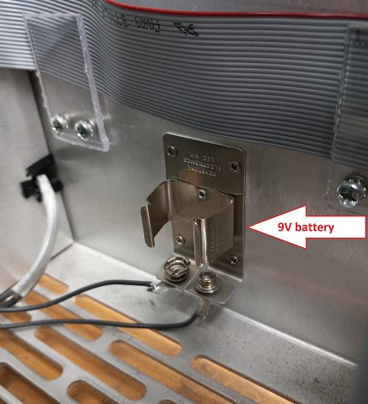

TOOLS AND PARTS NEEDED ARE BELOW
#1 Phillips screwdriver
¼” nutdriver or wrench
2 Ty-raps

